**BUG REPORT OF TEA DIARY APPLICATION**

**Name: -** Drashti Patel

**Device: -** Redmi Note 7 Pro

**Android Version: -** Android 10

**Apk Version: -** 1.2

**Bug Id: -** 1

**Module Name: -** Seller List

**Bug Description: -** It does not fire validation message without click on particular field.

**Steps: -**

1. Open Application
2. Click on seller list icon
3. Click on plus icon
4. Keep all fields blank
5. Click on save button

**Test Data: -**

1. Name: “”
2. Mobile: “”
3. Address: “”

**Expected Result: -** System should display or fire validation message without click on particular field.

**Bug Images: -**

**Bug Id: -** 2

**Module Name: -** Seller List

**Bug Description: -** Without Add Menu Item Seller will be added.

**Steps: -** 1) Open Application

2) Click on Seller List Icon

3) fill all Fields

4) Click on save button

5) In manage Menu Item without add menu items and Click on Save

**Expected Result: -** System should Can not be Go ahead without add Menu Item.

**Bug Images: -**

**Bug Id: -** 3

**Module Name: -** Seller List

**Bug Description: -** Back Button not available in Manage Menu Item

**Steps: -** 1) Open Application

2) Click on Seller List Icon

**Expected Result: -** System should available Back for user friendly

**Bug Images: -**

**Bug Id: -** 4

**Module Name: -** Seller List

**Bug Description: -** Seller list page is blank when seller is not added

**Steps: -** 1) Open Application

2) Click on Seller List Icon

**Expected Result: -** System should Fire Message “No Data available”.

**Bug Images: -**

**Bug Id: -** 5

**Module Name: -** Seller List

**Bug Description: -** Special Character accepted in name

**Steps: -** 1) Open Application

2) Click on Items Menu

3) Click on Plus icon

4) Enter Special Character in name field

**Test Data: -**

1) Name= “$”

2) Mobile no= “9898858588”

3) Address= “Godha”

**Expected Result: -** System should not accept special characters.

**Bug Images: -**

**Bug Id: -** 6

**Module Name: -** Seller List

**Bug Description: -** Numeric Value accepted in name

**Steps: -** 1) Open Application

2) Click on Items Menu

3) Click on Plus icon

4) Enter Numeric value in name field

**Test Data: -**

1) Name= “1234”

2) Mobile no= “9898858588”

3) Address= “Godha”

**Expected Result: -** System should not accept Numeric value.

**Bug Images: -**

**Bug Id: -** 7

**Module Name: -** Seller List

**Bug Description: -** Invalid number accepted in mobile no. filed and generated as 0.

**Steps: -**1) Open Application

2) Click on Seller list icon

3) Click on + icon

4) Enter name

5) Enter invalid Mobile no.

6) Enter Address

7) Click on Save

**Test Data: -**

1) Name= “Suresh Tea Stall”

2) Mobile no= “0000000000”

3) Address= “Godha”

**Expected Result: -** System should fire Validation Message “Please Enter Valid Mobile Number.”

**Bug Images: -**

**Bug Id: -** 8

**Module Name: -** Seller List

**Bug Description: -** Invalid number accepted in mobile no. field and generated as a “11111”

**Steps: -** 1) Open Application

2) Click on Seller list icon

3) Click on + icon

4) Enter name

5) Enter invalid Mobile no.

6) Enter Address

7) Click on Save

**Test Data: -**

1) Name= “Tea”

2) Mobile no= “0000011111”

3) Address= “Godha”

**Expected Result: -** System Should Fire Validation Message “Please Enter Valid Mobile number.”

**Bug Images: -**

**Bug Id: -** 9

**Module Name: -** Seller List

**Bug Description: -** Already available name accepted with case sensitive text in name field.

**Steps: -** 1) Open Application

2) Click on Seller list icon

3) Click on + icon

4) Enter name with case sensitive Value

5) Enter Mobile no.

6) Enter Address

7) Click on Save

**Test Data: -**

1) Name= “tea”

2) Mobile no= “9858989645”

3) Address= “Godha”

**Expected Result: -** System should fire validation message “Seller is already Available”

**Bug Images: -**

**Bug Id:** 10

**Module Name:** Seller List

**Bug Description:** Cursor focus is not placed on name field when name is blank

**Steps:**

1. Open Application
2. Click on the seller list icon
3. Click on + icon
4. Enter blank name
5. Enter Mobile
6. Enter Address
7. Click on Save

**Test Data:**

1. Name= “”
2. Mobile= “8585878985”

**Expected Result:** Cursor focus should be placed on blank name field

**Bug Images: -**

**Bug Id:** 11

**Module Name:** Seller List

**Bug Description:** Cursor focus is not placed on mobile no. field when mobile no. is blank

**Steps:**

1. Open Application
2. Click on the seller list icon
3. Click on + icon
4. Enter name
5. Enter blank Mobile
6. Enter Address
7. Click on Save

**Test Data:**

1. Name= “Triu”
2. Mobile= “”

**Expected Result:** Cursor focus should be placed on blank mobile no. field

**Bug Images: -**

**Bug Id:** 12

**Module Name:** Seller List

**Bug Description:** Already available name accepted with First letter capital in name field

**Steps:**

1. Open Application
2. Click on the seller list icon
3. Click on + icon
4. Enter name
5. Enter Mobile
6. Enter Address
7. Click on Save

**Test Data:**

1. Name= “tea”
2. Mobile= “7898564585”

**Expected Result:** Already available name accepted with case sensitive text in name field

**Bug Images:**

**Bug Id:** 13

**Module Name:** Seller List

**Bug Description:** Blank Space is accepted in name and address filed

**Steps:**

1. Open Application
2. Click on the seller list icon
3. Click on + icon
4. Enter blank space in name
5. Enter Mobile
6. Enter blank space in Address
7. Click on Save

**Test Data:**

1. Name= “”
2. Mobile= “9856332554”
3. Address= “”

**Expected Result:** System should fire validation message “Please enter valid name and address”

**Bug Images:**

**Bug Id:** 14

**Module Name:** Seller List

**Bug Description:** When press back button it redirect to homepage from manage menu page.

**Steps:**

1. Open Application
2. Click on the seller list icon
3. Click on + icon
4. Enter name
5. Enter Mobile
6. Enter Address
7. Click on Save
8. Redirect to manage menu
9. Press back button

**Test Data:**

1. Name= “Drashti”
2. Mobile= “8974585888”
3. Address= “Xyz”

**Expected Result:** User should redirect to seller list

**Bug Images:**

**Bug Id:** 15

**Module Name:** Seller List

**Bug Description:** Emoji accepted in name field

**Steps:**

1. Open Application
2. Click on the seller list icon
3. Click on + icon
4. Enter emoji in name
5. Enter Mobile
6. Enter Address
7. Click on Save

**Test Data:**

1. Name= “Emoji”
2. Mobile= “9658785852”
3. Address= “QAWS”

**Expected Result:** System should fire validation message” Please enter valid name”

**Bug Images:**

**Bug Id:** 16

**Module Name:** Seller List

**Bug Description:** Heading is not proper when click on delete button

**Steps:**

1. Open Application
2. Click on the seller list icon
3. Click on + icon
4. Enter name
5. Enter Mobile
6. Enter Address
7. Click on Save
8. Tap on user’s detail
9. Click on Delete

**Test Data:**

1. Name= “Drashti”
2. Mobile= “9785842522”
3. Address= “Hi”

**Expected Result:** System should fire validation message “Please enter valid name and address”

**Bug Images:**

**Bug Id:** 17

**Module Name:** Seller List

**Bug Description:** User redirect to homepage when press back button from + icon

**Steps:**

1. Open Application
2. Click on the seller list icon
3. Click on + icon
4. Press back button

**Expected Result:** User should be redirect to Seller list

**Bug Images:**

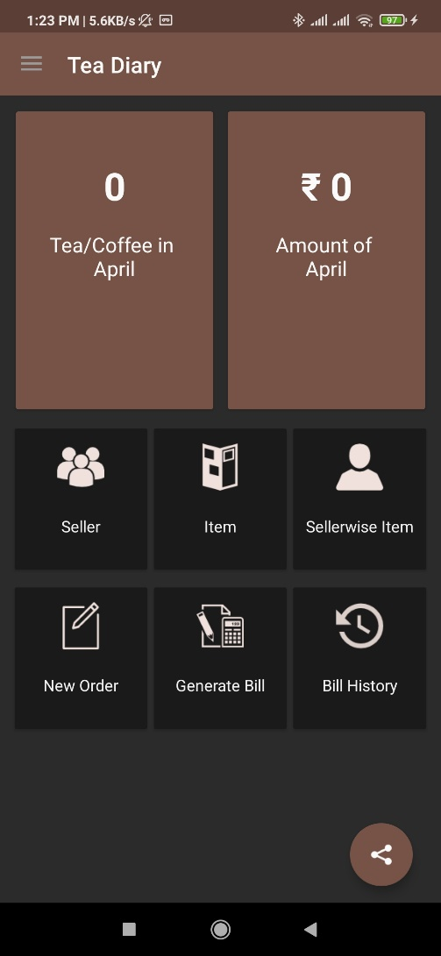

**Bug Id:** 18

**Module Name:** Item List

**Bug Description:** Validation message is not in proper place when both fields are blank

**Steps:**

1. Open Application
2. Click on the Item list icon
3. Click on + icon
4. Click on Save

**Test Data:**

1. Name= “”
2. Price= “”

**Expected Result:** Validation message should be in proper place

**Bug Images:**

**Bug Id:** 19

**Module Name:** Item List

**Bug Description:** Price deleted when click on price tab

**Steps:**

1. Open Application
2. Click on the Item list icon
3. Click on one of the items
4. Enter item name
5. Enter Price
6. Click on Update

**Test Data:**

1. Name= “Tea”
2. Price= ”10”

**Expected Result:** Price should not be deleted when user enter the price

**Bug Images:**

**Bug Id:** 20

**Module Name:** Item List

**Bug Description:** Cursor focus is not placed on name when item name is blank

**Steps:**

1. Open Application
2. Click on the Item list icon
3. Click on + icon
4. Enter blank item name
5. Enter Price
6. Click on Save

**Test Data:**

1. Name= “”
2. Price= “10”

**Expected Result:** Cursor focus should be placed on blank item name field

**Bug Images:**

**Bug Id:** 21

**Module Name:** Item List

**Bug Description:** Cursor focus is not placed on price when price is blank

**Steps:**

1. Open Application
2. Click on the Item list icon
3. Click on + icon
4. Enter item name
5. Enter blank Price
6. Click on Save

**Test Data:**

1. Name= “Tea”
2. Price= “”

**Expected Result:** Cursor focus should be placed on blank price field

**Bug Images:**

**Bug Id:** 22

**Module Name:** Item List

**Bug Description:** Already available product accepted with case sensitive text in item name field

**Steps:**

1. Open Application
2. Click on the Item list icon
3. Click on + icon
4. Enter item name with case sensitive text
5. Enter Price
6. Click on Save

**Test Data:**

1. Name= “Tea”
2. Price= “20”

**Expected Result:** System should fire validation message “Product is already Available”

**Bug Images:**

**Bug Id:** 23

**Module Name:** Item List

**Bug Description:** Blank space accepted in item name field

**Steps:**

1. Open Application
2. Click on the Item list icon
3. Click on + icon
4. Enter blank space in item name
5. Enter Price
6. Click on Save

**Test Data:**

1. Name= “”
2. Price= “20”

**Expected Result:** System should fire validation message “Please enter valid item name”

**Bug Images:**

**Bug Id:** 24

**Module Name:** Item List

**Bug Description:** Numeric value accepted in item name field

**Steps:**

1. Open Application
2. Click on the Item list icon
3. Click on + icon
4. Enter numeric value in item name
5. Enter Price
6. Click on Save

**Test Data:**

1. Name= ”1”
2. Price= “10”

**Expected Result:** System should fire validation message “Please enter valid item name”

**Bug Images:**

**Bug Id:** 25

**Module Name:** Item List

**Bug Description:** Special character accepted in item name field

**Steps:**

1. Open Application
2. Click on the Item list icon
3. Click on + icon
4. Enter special character in item name
5. Enter Price
6. Click on Save

**Test Data:**

1. Name= “@”
2. Price= “20”

**Expected Result:** System should fire validation message “Please enter valid item name”

**Bug Images:**

**Bug Id:** 26

**Module Name:** Item List

**Bug Description:** Emoji accepted in item name field

**Steps:**

1. Open Application
2. Click on the Item list icon
3. Click on + icon
4. Enter emoji in item name
5. Enter Price
6. Click on Save

**Test Data:**

1. Name= “emoji”
2. Price= “10”

**Expected Result:** System should fire validation message “Please enter valid item name”

**Bug Images:**

**Bug Id:** 27

**Module Name:** Item List

**Bug Description:** Max length of Item name is not valid/proper

**Steps:**

1. Open Application
2. Click on the Item list icon
3. Click on + icon
4. Enter max length of the item name
5. Enter Price
6. Click on Save

**Test Data:**

1. Name= “Cold Coffee”
2. Price= “50”

**Expected Result:** Max length should be proper in item name field

**Bug Images:**

**Bug Id:** 28

**Module Name:** Item List

**Bug Description:** Redirect to homepage when press back button from add new item page

**Steps:**

1. Open Application
2. Click on the Item list icon
3. Click on + icon
4. Enter item name
5. Enter Price
6. Press back button

**Expected Result:** User should redirect to Item list

**Bug Images:**

**Bug Id:** 29

**Module Name:** Item List

**Bug Description:** Already available item name accepted when user update item name field

**Steps:**

1. Open Application
2. Click on the Item list icon
3. Click on + icon
4. Enter item name
5. Enter Price
6. Click on Save
7. Click on one of the items
8. Update item name
9. Click on Update

**Test Data:**

1. Name= “Tea”
2. Price= ”20”

**Expected Result:** System should fire validation message “Product is already Available”

**Bug Images:**

**Bug Id:** 28

**Module Name:** Seller wise Item

**Bug Description:** Cursor focus is not on proper place when check the checkbox and enter price

**Steps:**

1. Open Application
2. Click on Seller wise Item
3. Check the checkbox
4. Enter Price
5. Click on Ok

**Test Data:**

1. Price= “70”

**Expected Result:** Cursor focus should be in proper place

**Bug Images:**

**Bug Id:** 29

**Module Name:** Seller wise Item

**Bug Description:** Default price accepted when checkbox unchecked

**Steps:**

1. Open Application
2. Click on Seller wise Item
3. Checkbox unchecked
4. Enter Price
5. Click on Ok

**Test Data:**

1. Name= “Tea”
2. Price= “20”

**Expected Result:** System should be shown updated price

**Bug Images:**

**Bug Id:** 30

**Module Name:** Seller wise Item

**Bug Description:** Delete option is not available for remove item

**Steps:**

1. Open Application
2. Click on Seller wise Item
3. Click on add new item
4. Enter Name
5. Enter Price
6. Click on Save

**Test Data:**

1. Name= “Tea”
2. Price= “10”

**Expected Result:** Delete option should be available

**Bug Images:**

**Bug Id:** 31

**Module Name:** Seller wise Item

**Bug Description:** User redirect to homepage when click on save and press back button

**Steps:**

1. Open Application
2. Click on Seller wise Item
3. Select Tea Seller
4. Select item
5. Click on Save
6. Redirect to new order
7. Press back button

**Expected Result:** User should redirect to seller wise item

**Bug Images:**

**Bug Id:** 32

**Module Name:** New Order

**Bug Description:** Price tag is not in a proper place

**Steps:**

1. Open Application
2. Click on New Order

**Expected Result:** Price tag should be in proper place

**Bug Images:**

**Bug Id:** 33

**Module Name:** New Order

**Bug Description:** List is not updated after delete seller name

**Steps:**

1. Open Application
2. Click on New Order
3. Select Tea Seller
4. Click on place order
5. Delete seller from seller List

**Expected Result:** List should be updated after delete seller

**Bug Images:**

**Bug Id:** 34

**Module Name:** New Order

**Bug Description:** Order placed successfully for Postdates in calendar but not shown in list

**Steps:**

1. Open Application
2. Click on New Order
3. Select Tea Seller
4. Select date
5. Place Order

**Expected Result:** Boundary value should be checked for calendar

**Bug Images:**

**

**Bug Id:** 35

**Module Name:** New Order

**Bug Description:** Post dates are clickable (Not hidden)

**Steps:**

1. Open Application
2. Click on New Order
3. Select Tea Seller
4. Select date
5. Place Order

**Expected Result:** Postdates should be not clickable

**Bug Images:**

**Bug Id:** 36

**Module Name:** New Order

**Bug Description:** Order can’t delete after order placed

**Steps:**

1. Open Application
2. Click on New Order
3. Select Tea Seller
4. Select date
5. Place Order

**Expected Result:** After order placed user should be able to delete orders

**Bug Images:**

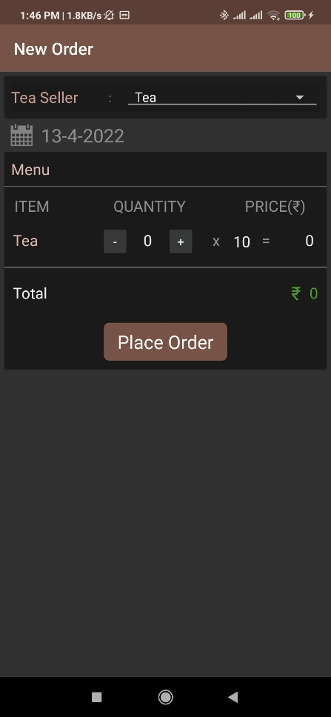

**Bug Id:** 37

**Module Name:** New Order

**Bug Description:** Redirect to homepage when click on place order button

**Expected Result:** User should redirect to order list

**Bug Images:**

**Bug Id:** 38

**Module Name:** New Order

**Bug Description:** In item Lists Keyboard is overlap

**Steps:**

1. Open Application
2. Click on New Order
3. Enter quantity manually

**Expected Result:** User should see the menu list by scroll down the screen

**Bug Images:**

**Bug Id**: 39

**Module Name:** Generate Bill

**Bug Description:** System accept “From” date greater than “To” date

**Steps:**

1. Open Application
2. Click on Generate bill
3. Click on “From” dates
4. Select one date is greater than “To” date

**Expected Result:** System should not be able to choose invalid date

**Bug Images:**

**Bug Id:** 40

**Module Name:** Bill History

**Bug Description:** Zero amount accept in paid amount field

**Steps:**

1. Open Application
2. Click on bill History
3. Click on one of the lists
4. Click on pay
5. Enter 0

**Expected Result:** Zero amount should not be acceptable in paid amount field

**Bug Images:**

**Bug Id:** 41

**Module Name:** Seller

**Bug Description:** Trimmed value accepted in name field

**Steps:**

1. Open Application
2. Click on Seller list
3. Click on + icon
4. Enter trimmed value in name

**Test Data:**

1. Name= “ Drashti”

2. Mobile= “9858965666”

3. Address= “Godha”

**Expected Result:** System should fire validation message “Please enter valid name”

**Bug Images:**

**Bug Id:** 42

**Module Name:** Dashboard

**Bug Description:** Link is not working when click on share button and sent the link

**Steps:**

1. Open Application
2. Click on Share button multiple times
3. Share link with any applications

**Expected Result:** Application link should be working and redirect to specific page

**Bug Images:**

**Bug Id:** 43

**Module Name:** Dashboard

**Bug Description:** Multiple times popup generate when click on share button multiple times

**Steps:**

1. Open Application
2. Click on Share button multiple times
3. Press back button of the device

**Expected Result:** Popup should be generated only one time

**Bug Images:**

**Bug Id:** 44

**Module Name:** Tea/Coffee List

**Bug Description:**  Order details is not generated properly when click on one of the lists

**Steps:**

1. Open Application
2. Click on Tea/Coffee list
3. Tap on one of the lists

**Expected Result:** System should be generated valid proper details

**Bug Images:**

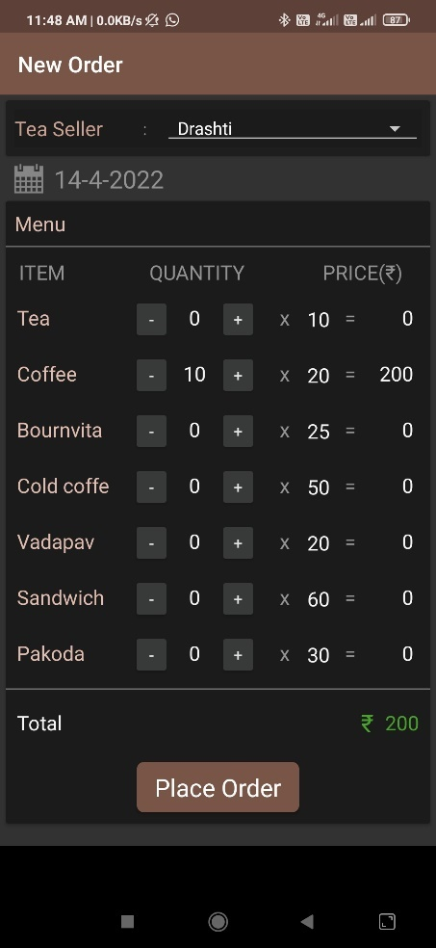

**Bug Id:** 45

**Module Name:** Bill History

**Bug Description:** Latest bill is generated on last with same date

**Expected Result:** Latest bill generated should be on top

**Bug Images:**

**Bug Id:** 46

**Module Name:** Tea/Coffee List

**Bug Description:**  Seller name is not updated when change seller name from order details

**Steps:**

1. Open Application
2. Click on Tea/Coffee list

**Expected Result:** Seller name should be updated from the order details.

**Bug Images:**

**Bug Id:** 47

**Module Name:** Tea/Coffee List

**Bug Description:** Multiple Seller’s orders are generated at a time

**Steps:**

1. Open Application
2. Click on Tea/Coffee list

**Expected Result:**  One seller’s order should be generated at a time

**Bug Images:**

**Bug Id:** 48

**Module Name:** All modules

**Bug Description:**  Back button is not available in all modules

**Expected Result:** Back button should be available for all modules

**Bug Images:**

